Data Project #5

**Submitted By:** Maaz Siddiqui

**Submitted on: 6/14/2020**

**Due Date:**

**6/14/2020**

Summer 2020

**Course Code: MATH 2930**

**Effect of Placement on Product Sales**

An experiment was conducted to determine the effect of placement of a product in a small organic food store.[1] This change was conducted because the owner of the store was concerned about their sales for a specialty yoghurt which was manufacture in Greece. Increase in fuel prices had forced her to increase the price of the yoghurt. So, the owner decided to place the product on a shelf which was near eye level for majority of the customers. In addition, it was kept in the area along with other international products. The number of containers sold each week was recorded for 24 weeks (six months) for both before and after the change of location/placement was done. This study is important because it shows how small businesses can take steps to increase their revenue for individual product sales. In this study, sales for the specialty yoghurt are being impacted because of the rise in fuel prices. Thus, the owner is taking steps to ensure that the impact is a positive one rather than a negative one. The results from this study can be used by her to increase product sales in future as needed.

The first set of plots display normality in the number of containers sold before and after the change of location for the yoghurt product. It is evident that at both times the data is normally distributed about the true mean for their respective times. Identifying how the data is distributed will help in calculating descriptive statistics.

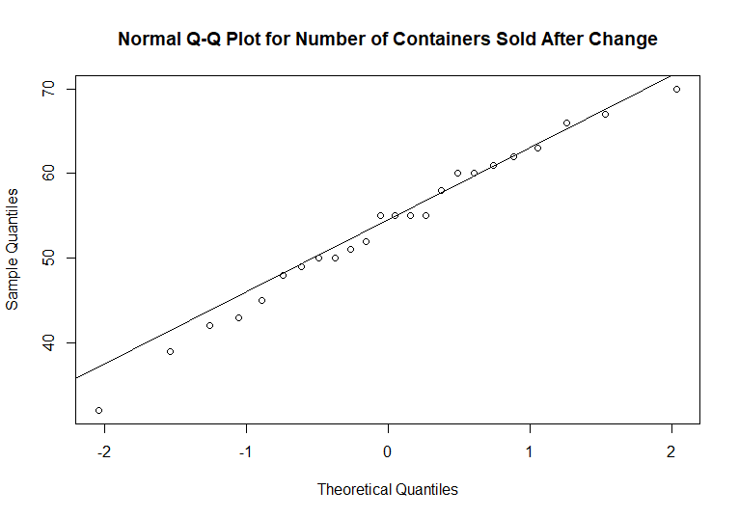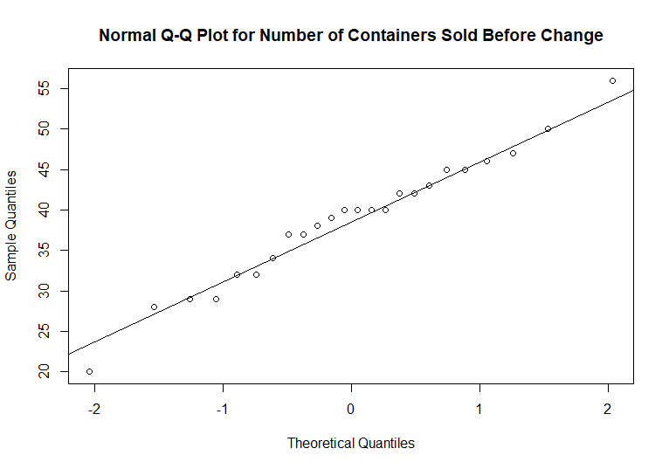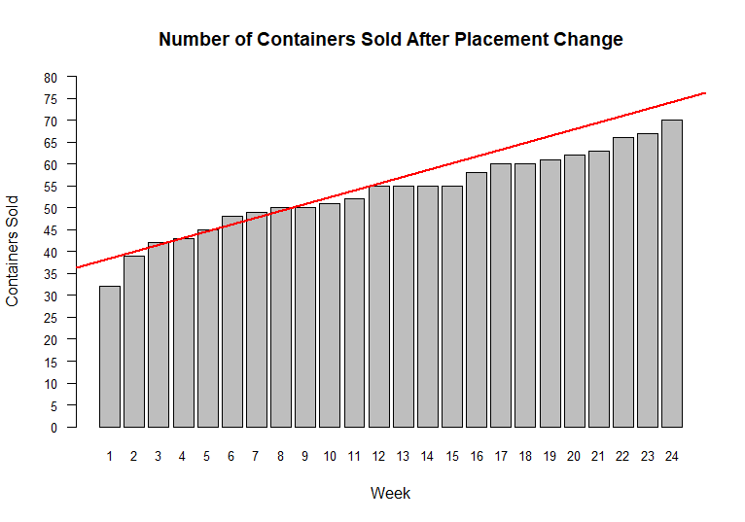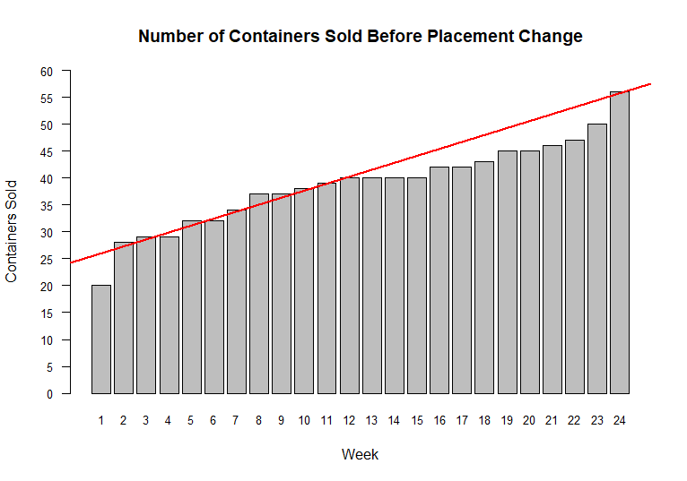

The second set of plots displays the whether there is an increasing trend or decreasing trend in containers sold for the specialty yoghurt. In both situations there is linearly increasing trend. However, the trend of the second graph is more important because it displays whether the change of location had an effect on container sold or not. In this case, it is evident that the change has positively impacted the number of containers sold of the specialty yoghurt.

Let’s assume, that before this study was conducted, the owner hypothesized that after the location of the specialty yoghurt is changed, as described previously, the average number of yoghurt containers sold will increase. This means that the null hypothesis is that there will no difference between average number of yoghurt containers sold before and after the change. The alternate hypothesis is that there will be an increase in the average number of yoghurt containers sold after the change in location. After the experiment is conducted, the owner has been given some descriptive statistics:

* Sample mean of yoghurt containers sold (before change) $=38.792$
* Sample standard deviation (before change) $=7.929$
* Sample mean of yoghurt containers sold (after change) $=53.66754$
* Sample standard deviation (after change) $=9.356$
* Sample mean difference $=14.875$
* $95\%$ Confidence Interval (lower bound) $=14.165$
* T-Statistic $=35.927$, Degrees of freedom $=23$
* $p$-value $=2.2×{10}^{-16}$

Therefore, it can be inferred that there is a $95\%$ chance that the population mean will be greater than $14.165$. In addition, it can be concluded that there is very strong evidence to support the claim that the average number of yoghurt containers sold will increase after the location of the specialty yoghurt products is changed.

1. <https://dasl.datadescription.com/datafile/product-placement/>